CHAPTER 1
Explaining Mechanisms vs. Organisms
Early breakthroughs with respect to explaining mechanisms (e.g., clocks) or inanimate things (e.g., colliding billiard balls) have shaped the narratives that dominated early science. The scientific explanations of mechanisms were based on causal narratives with a strict ordering in time such that causes always preceded effects. Thus, explaining an action (an effect or a response) involved tracing back along a sequence of actions until you find a satisfying explanation (i.e., the primary cause). This resulted in a metaphorical string of dominos that is conveniently decomposable in time. That is, it is possible to isolate steps in the sequence (pairs of dominos), and it is possible to identify local and remote causes of an action. This led to experimental approaches that isolated small sequences of actions to test specific hypotheses, with the promise that the understanding of these isolated parts (e.g., gears) could be combined to explain the entire sequence (e.g., behavior of the clock). In fact, there was an implication that it would ultimately be possible to explain the entire universe by isolating the first, primary domino and then tracing forward along the causal chain to predict the future.
It is not too surprising that early biologists and social researchers adopted this same narrative in their attempts to develop a scientific approach to explaining the actions of organisms. This is clearly illustrated by the stimulus response (SR) explanations of behavioral psychologists, or the decomposition of cognition into an ordered series of discrete information processing stages. It is also why analogies to mechanisms – clockworks, servomechanisms, and computers have been accepted as satisfying explanations by many social scientists.
However, it is becoming increasingly evident that the causal narrative that was successful for explaining the behavior of mechanisms will not lead to satisfying explanations for the behavior of organisms.¹ In fact, there is growing suspicion that this causal narrative also falls short with respect to understanding complex physical systems (e.g., weather systems² or dripping faucets³). Thus, if the goal is to explain the behavior of organisms it becomes necessary to develop an alternative to the causal narrative.

Problems with a Causal Narrative
Let’s consider some of the reasons why the causal narrative does not lead to a satisfying explanation for the behavior of organisms. First, the behavior of organisms is shaped by the potential consequences of actions. This is reflected in the fact that organisms pursue goals. This does not fit with the assumption that causes precede action. Thus, for example, William Powers’ Perceptual Control Theory (PCT)⁴ suggests that organisms control perceptions, not actions. Consider driving down the highway. PCT suggests that your actions on the steering wheel are being determined (caused) by the perceptions of the position and direction of travel of your car with respect to the road (or intended path). In other words, you are not controlling your arms or the steering wheel, you are controlling the perceived consequences of those actions relative to your intention to keep your car in the proper lane.
Others might say that the actions are being determined by your intended destination, or the ‘why’ of your travel. The broader implication, however, is that the coupling between stimuli and actions can be bi-directional or circular. In a circle, there is no longer a fixed precedence in time – there is no sense in which any processing stage is necessarily prior to any other stage in the circle.
In a circle, there is no longer a fixed precedence in time – there is no sense in which any processing stage is necessarily prior to any other stage in the circle.

This circular coupling can be represented by adding feedback to the typical information processing model of cognition. However, early representations of information processing with feedback tended to preserve a fixed ordering in time consistent with a causal narrative in which sensing precedes perception, which precedes decision making, which precedes action. This implicit precedence is inconsistent with the circular dynamic that results from adding feedback.
In the circle there is no sense in which any information processing stage necessarily precedes any other stage. For example, Gibson⁶ observed that feet were a critical component of visual perception because movement is necessary to create the visual flow fields that specify our relations to the surfaces in our ecology. Figure 1.1 below shows the conventional representation of information processing and an equivalent model that implies an alternative precedence between stages. The key point is that these representations are equivalent – illustrating that within the circle there is no fixed precedence in time between the stages of processing.⁶

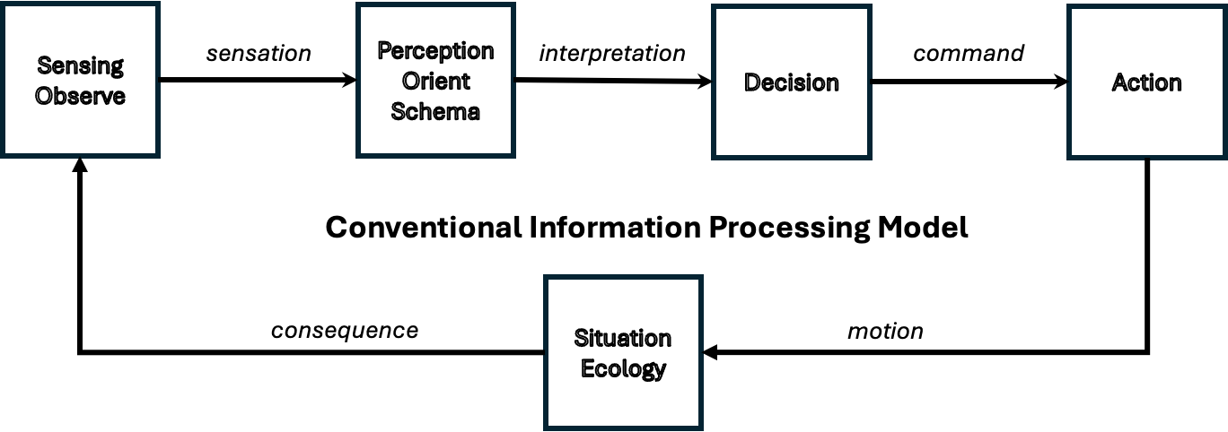

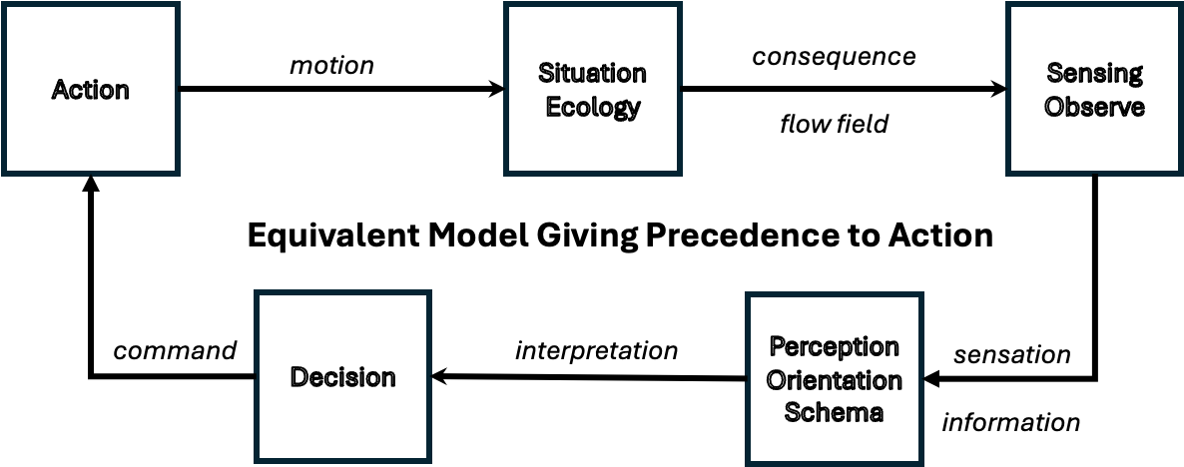
Figure 1.1
A second problem with the mechanistic narrative is that there is an implication that the transfer functions of the elements (e.g., the behavior of dominos or information processing stages) are fixed. This implies that pairs of dominos or stages of processing can be isolated and studied independently from the other dominos or stages, and that eventually the behavior of an organism could be explained by combining knowledge obtained by studying the independent elements. For example, it implies that decision making could be understood independently from sensing, perception, or action. However, research on Naturalistic Decision Making⁷ illustrates that decision making is not independent from recognition stages (e.g., selective attention and framing of the situation). And research on perception and action illustrates that a primary function of perception is to tune into the information that specifies the opportunities or constraints on action (i.e., the affordances)⁸.
The need for the stages to interact and change (i.e., to learn or adapt) was recognized by Piaget⁹ with respect to cognitive development and by Boyd¹⁰ with respect to the development of skill or expertise. Piaget described two dynamics with respect to cognitive processes – assimilation and accommodation. Figure 1.2 illustrates parallels between Piaget’s theories of cognitive development and Boyd’s model of creation and destruction in the OODA loop. Note that in most prior representations of cognitive processes the ecology or situation is implicit. However, just as it is important to consider the topology in order to predict the flow of a river, it is important to consider the ecology in order to predict the flow of cognition.
Assimilation is reflected in the forward loop. This reflects how internal schemas (intentions and expectations) guide our interactions with the ecology. That is, the schema directs our attention and helps us to guess what actions will lead to satisfying interactions with our ecology. For Boyd this is analogous to creative action (creation). If our guesses are correct, then the resulting feedback will confirm or reinforce the schema as a satisfying framing for productive action.
However, sometimes we will be surprised. That is, the consequences will not be consistent with our expectations. The upper loop reflects what Piaget called accommodation and what Boyd called destruction. The feedback in this loop changes our schema (e.g., it adapts or destroys our old model or old assumptions to accommodate the unexpected consequences). That is, the transfer function for the box labeled schema is not fixed or stationary. The transfer function changes as a result of surprising consequences. This reflects the capacity of organisms to adapt or learn from experience. Piaget referred to this adaptive learning process as equilibration. It reflects the ability to seek a balance or equivalence between what we expect to happen (assimilation) and what actually happens (accommodation). Ideally, the equilibration processes lead to a continually improving attunement to the pragmatic demands of one’s ecology.
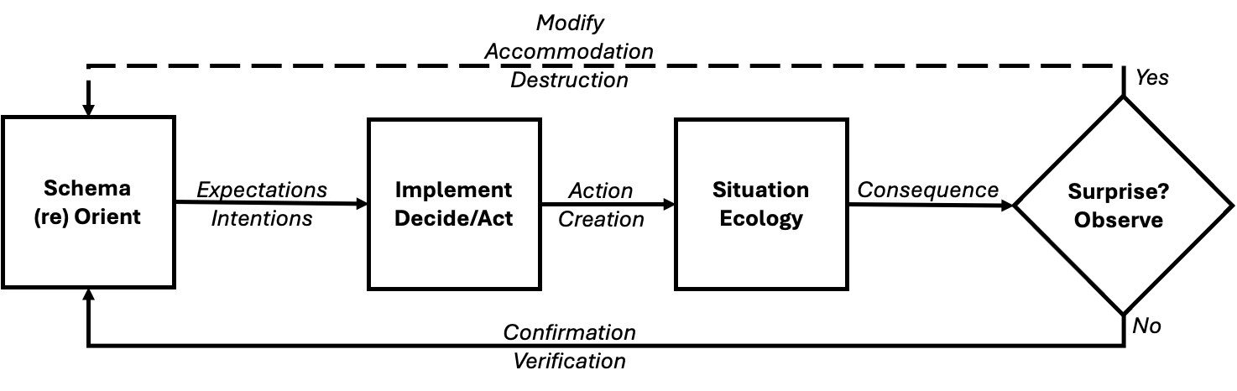
Figure 1.2
Note that the solid lines in block diagrams conventionally represent signals that are processed or transformed by each stage into a new signal that is passed to the next stage. However, the stages are generally considered to be fixed processes that are not changed by the signals that they receive. I have used a dotted line for the accommodation feedback, to indicate that it operates on the schema – changing it to reflect what is learned from the surprise.
Thus, organisms are more complex than simple servomechanisms or computers with fixed transfer functions specified by the engineer or programmer. They are engaged in a constant process of attunement to create a stable coupling with the ecology. In other words, the survival of organisms depends on learning about and adapting to their ecology. A critical insight here is that stability is a constraint on the animal/ecology system (i.e., the coupling of organisms with their environment). This reverses the narrative with respect to parts and wholes. Rather than the whole being the sum of the parts, in a circular dynamic, the parts must satisfy the stability constraints on the whole circuit, which includes the ecology. For example, if the ecology changes, the organism must also change in a way that maintains stability. Otherwise, the organism will become extinct. In other words, survival of the organism depends on maintaining a stable coupling with its ecology – the transfer function of the organism must change (adapt) to meet the stability constraints of the coupling.
Rather than the whole being the sum of the parts, in a circular dynamic, the parts must satisfy the stability constraints on the whole circuit, which includes the ecology.

McRuer’s crossover model¹¹ of how humans adapt to changing dynamics in a tracking task is a great illustration of how the transfer function of a human tracker must change to meet the demands of stability. If the transfer function of the plant is a simple gain (position control), then the human transfer function must have the properties of an integrator. But if the plant transfer function is an integrator (1st-order, velocity control), then the human transfer function must have the properties of a gain. The combined dynamic of human plus plant must meet the stability requirements of the entire loop (i.e., must be a low-pass filter). Thus, the human transfer function must change to complement changes in the plant dynamic. Otherwise, the system (human + plant) will be unstable. (this will be discussed in more depth in the Controllability Chapter).
You could also think about this in the context of competitive sports like tennis. To be consistently successful against different opponents it is necessary to adapt your style of play (your transfer function) in a way that counters the different strengths and weaknesses of each of your opponents. Or consider what happens when you drive a strange car that might have worse or better brakes than the car you drive routinely. Your first attempt to apply the brakes in the unfamiliar vehicle might have a surprising consequence. However, you are able to quickly accommodate to the new brakes, so that after a few attempts you can brake smoothly. Essentially, you are adjusting your own ‘transfer function’ to achieve a comfortable drive (i.e., stable control).
Another aspect of the dynamic of circles that is inconsistent with the causal narrative is that the dynamics of circles cannot be dissected into a series of discrete instances in time (e.g., one domino or billiard ball hitting another in a series of discrete collisions). There is not a single discrete signal in the information processing circle that then moves from one stage to the next. Rather, all stages are getting signals continuously. For example, you don’t have a sensation that becomes a perception that then drives a decision which then becomes an action, leading to the next perception, etc. Rather, the organism is continuously sensing, which is continuously being integrated into ongoing perceptions, that informs ongoing decisions, that are integrated into ongoing actions. Further, the constraint on stability is not in time, it is over time. In other words, organisms are composed of continuous, analog processes. Again, consider driving, you are continuously monitoring conditions, assessing the potential risks, and acting to keep within the safe field of travel.
There is not a single discrete signal in the information processing circle that then moves from one stage to the next. Rather, all stages are getting signals continuously.

Finally, organisms are not processing single signals in one or two loops. Rather organisms are simultaneously dealing with a multitude of signals that are percolating through a multilayered network with many loops. This includes sensing through multiple modalities, perceiving multi-dimensional situations, and directing and coordinating the actions of multiple effectors relative to a range of short- and long-range goals and values. Thus, organisms are not reacting to discrete particles like colliding billiard balls. Rather, they are managing fields of information and coordinating fields of effectors. In motor control, this is reflected in the degrees of freedom problem¹² – how to produce consistent outcomes under varying situations. For example, coordinating multiple muscles and joints to consistently achieve the same ends (e.g., an accurate throw to first base) under a wide range of different situations (e.g., reflecting different postures resulting from the need to first retrieve a ground ball).
Organisms are not reacting to discrete particles like colliding billiard balls. Rather, they are managing fields of information and coordinating fields of effectors.
The bottom line is that much of the biological and social sciences are framed within a causal narrative that was designed to explain inanimate mechanisms.

A New Narrative
Thus, it is becoming increasingly obvious to many researchers that the classical causal narrative does not lead to satisfying explanations for how organisms behave. Today a new narrative is being created based on the capacity of the organism to resiliently adapt to situated constraints. Rather than looking for causes, researchers are beginning to explore how behavior is shaped by constraints on perception and action. They are asking how patterns in fields of information (e.g., perceptual invariants) specify the opportunities and risks for action (e.g., affordances), relative to the successful pursuit of satisfying ends (e.g., healthy consequences, stable balance with the ecology, survival).¹³
Today a new narrative is being created based on the capacity of the organism to resiliently adapt to situated constraints. Rather than looking for causes, researchers are beginning to explore how behavior is shaped by constraints on perception and action. They are asking how patterns in fields of information (e.g., perceptual invariants) specify the opportunities and risks for action (e.g., affordances), relative to the successful pursuit of satisfying ends (e.g., healthy consequences, stable balance with the ecology, survival).
The intention of this book is to reframe the narrative about the behavior of organisms and social organizations in a way that is more consistent with the dynamics of circular or coupled systems. The term ‘muddling,’ that was coined by Lindblom¹⁴ to describe the way political organizations make decisions, will be used as a label for the underlying dynamic.
In thinking about muddling, here are three seeds to keep in mind:
- Organisms learn from their mistakes.
- An organism never steps into the same stream twice.
- General principles are derived from specific events, while specific events are understood in the context of general principles.¹⁵
The first two seeds help to describe the challenge that organisms face. While they learn through the errors and surprises that are experienced in the past, what they learn must be generalized and applied through actions in a future that may be different from the past in important ways. For example, consider sports competitions where athletes must eventually face opponents who have different strengths and who are changing their own skills in a quest to gain a competitive advantage. This challenge is also recognized by military science which warns against the danger of ‘fighting the last war.’ Again, recognizing that future opponents are likely to adopt very different tactics and strategies than prior opponents. In sum, the point is that our learning will generally be tested under conditions that are different than the conditions existing at the time we did the learning.
The third seed suggests that to generalize and apply what is learned from the past to the future it is necessary to go beyond the details of specific situations to extract more general patterns, heuristics, standards, or principles. Addressing the challenge of a constantly changing future requires multiple layers of understanding. It suggests that learning requires some degree of abstraction in order to apply what was learned from the errors and surprises from the last tennis match (or the last war) to the next.
The point is that muddling refers to the process of abstracting from the past to make smart hypotheses about the future! But it is important to realize that even smart hypotheses are guesses, and that errors and surprises are inevitable. Yet, despite a limited ability to forecast the future, people can often muddle through to achieve some degree of satisfaction in their lives.
A Next Step
In the next few chapters, some observations from the design of control systems and filters will be explored. Although it is a mistake to think that organisms are servomechanisms or even more sophisticated engineered control systems, learning about the dynamics of engineered control systems and filters is a useful first step to escaping from the traditional causal narrative that most of us have grown up with. This is a first step toward understanding organisms as self-designing systems.¹⁶
For the most part, mechanisms don’t muddle, at least not to the extent that organisms muddle. However, the engineers designing autonomous or semi-autonomous systems do extensive muddling in the design process to create mechanisms that will stably perform in well-defined situations. Thus, one can gain a lot of insight into the nature of the muddling processes of organisms from considering how engineers addressed the equilibration problems for their systems. Specifically, we will look at the problem of observability in the next chapter; the problem of controllability in the following chapter; and then we will consider the need to coordinate observability and controllability to satisfy a design intent.
Although mechanisms don’t muddle, extensive muddling is involved in the design of these mechanisms. So, rather than making analogies to the products of engineers, it is necessary to consider the design processes, if the goal is to generate productive insights about the muddling of organisms.

NOTES:
1. Juarrero, Alicia. (1999). Dynamics in Action. Cambridge, MA: MIT Press.
2. E.N. Lorenz. (1993). The essence of chaos. Seatle, WA: University of Washington Press. Work on modeling weather systems led to description of the ‘Butterfly Effect’ in which a small event like the flap of a butterfly’s wing could have a big impact on the behavior of a nonlinear system such as weather.
3. R. Shaw (1984). The dripping faucet as a model chaotic system. Santa Cruz, CA: Aerial Press. Shaw notes that “systems made up of a number, even a small number, of subunits can behave in ways which completely transcend our present understanding.”
4. Powers, W.T. (1973). Behavior: The control of perception. Chicago: Aldine de Gruyter.
5. J.J. Gibson (1979). The ecological approach to perception. Boston, MA: Houghton Mifflin Company.
6. R.J. Jagacinski & J.M. Flach (2003). Control theory for humans. Mahwah, NJ: Erlbaum. See figure 1.1 and related discussion of circular dynamics.
7. G.A. Klein (1993). A recognition-primed decision (RPD) model of rapid decision making. Ablex Publishing.
8. Rob Gray has a series of books related to the development and coaching of sports skills: https://perceptionaction.com/book/
9. Piaget, J. (1985). The equilibration of cognitive structures: The central problem of intellectual development. (T. Brown & K. J. Thampy, Trans.). University of Chicago Press. (Original work published 1975)
10. Osinga, Frans P.B. (2007). Science, Strategy, and War. New York: Routledge. This book provides a nice overview of John Boyd’s work.
11. Jagacinski, R.J. & Flach (2003). Control theory for humans. Mahwah, NJ: Erbaum. Extensive discussions of McRuer’s Crossover Model can be found in Ch. 14-15. See Fig. 14.6 for a visual illustration of how people adapt to meet the stability constraints.
12. Bernstein, N. (1967). The coordination and regulation of movements. Oxford: Pergamon Press. Bernstein wrote that one of the basic difficulties of motor co-ordination was the abundance of degrees of freedom, which is beyond the control capacity of a centralized control system.
13. Flach, J.M. & Voorhorst, F. (2020). A meaning processing approach to cognition. New York: Routledge. They identify three sources of constraint within the cognitive processing dynamic: specifying, affording, and satisfying.
14. Lindblom, C. (1959). The Science of Muddling Through. Public Administrative Review, 19(2), 79-88. Lindblom, C. (1979). Still Muddling, Not Yet Through. Public Administrative Review, 39(6), 517-526. Written 20 years apart, the first paper describes organizational decision making as an incremental muddling process. The second paper makes the case that ‘muddling’ is not just a description, but it is a prescription for how organizations effectively manage uncertainty through an incremental trial and error process.
15. This seed is a variation of a quote from Ernst Cassire: “It is, as it were, the fundamental principle of cognition that the universal can be perceived only in the particular, while the particular can be thought only in reference to the universal.” Ernst Cassire (1965). The Philosophy of Symbolic Forms, Volume 1. Yale University Press.
16. Bejan, A. & Zane, J.P. (2012). Design in Nature. New York: Anchor Books.

